**BACK-END DEVELOPMENT OF ERD DIAGRAM**

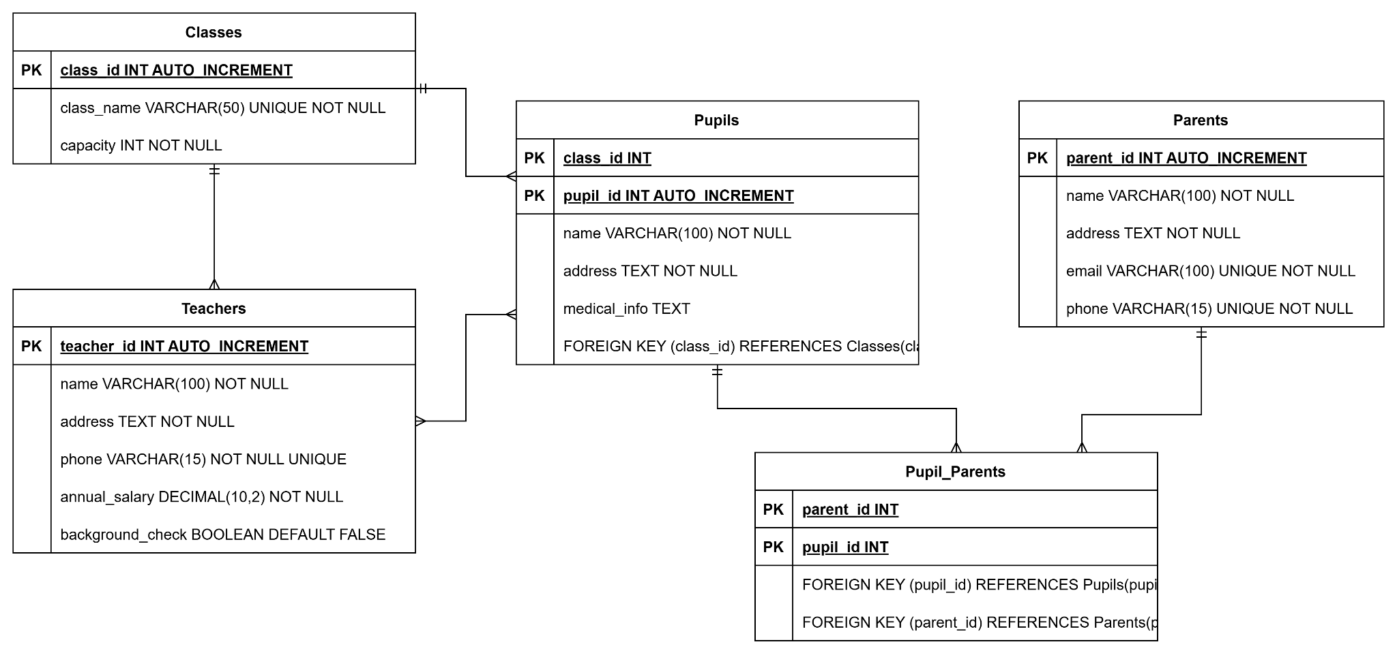

**Figure 1: ERD of the System**

(Source: Made by self in draw.io)

This entity relationship diagram (ERD) shows a school management database system that involves five main entities: Classes, Teachers, Pupils, Parents, and Pupil_Parents. The Class entity has ClassID and ClassName as attributes with ClassID being the primary key. Each class has a particular teacher, with TeacherID acting as the foreign key in a one-to-many relation from Teachers to Classes. The Teacher entity contains TeacherID as a primary key with other attributes being FirstName, LastName, and Subject. Each teacher can take multiple classes.

The Pupil entity consists of attributes including PupilID (primary key), FirstName, LastName, and DOB (Date of Birth), thereby identifying foreign key ClassID linking each pupil to one class. Hereby creating a many-to-one relationship from Pupils to Classes. Parents have the ParentID (the primary key), FirstName, LastName, and Phone. This is a many-to-many relation between Pupils and Parents since one parent can enroll multiple children, and one child can have multiple parents/guardians.

To facilitate this many-to-many relationship, a junction entity has been created, Pupil_Parents, with composite primary keys of PupilID and ParentID. This ERD represents a real-life educational setting that efficiently encompasses relationships among pupils, their classes, teachers, and guardians.